**Elasticity of Demand**

**Cross Elasticity of Demand**

**Q1**. When the price of cheese increases by 40 percent, the quantity demanded of pizza decreases by 60 percent.

What is the cross-price elasticity of demand for pizza and cheese?

**Q2**. If the cross price elasticity between butter and peanut butter is 2, which is correct?

a. The two goods are complements, and a price increase in one good will cause an increase in the quantity demanded of the other.

b. The two goods are independent, and a price increase in one good will cause an increase in the quantity demanded of the other.

c. The two goods are substitutes, and a price decrease in one good will cause an increase in the quantity demanded of the other.

d. The two goods are substitutes, and a price increase in one good will cause an increase in the quantity demanded of the other.

Answer: d.

**Q3**. If the price of honey rises from Tk. 45 per 250 grams to TK. 55 per 250 grams per pack and as a result the consumer’s demand for sugar increases from 600 to 800 packs then find the cross elasticity of demand of honey for sugar. State the relationship between the two goods.

Price Elasticity of Supply

**Q4.** Given the following data for the supply and demand of movie tickets, calculate the price

elasticity of supply when the price changes from $9.00 to $10.00.

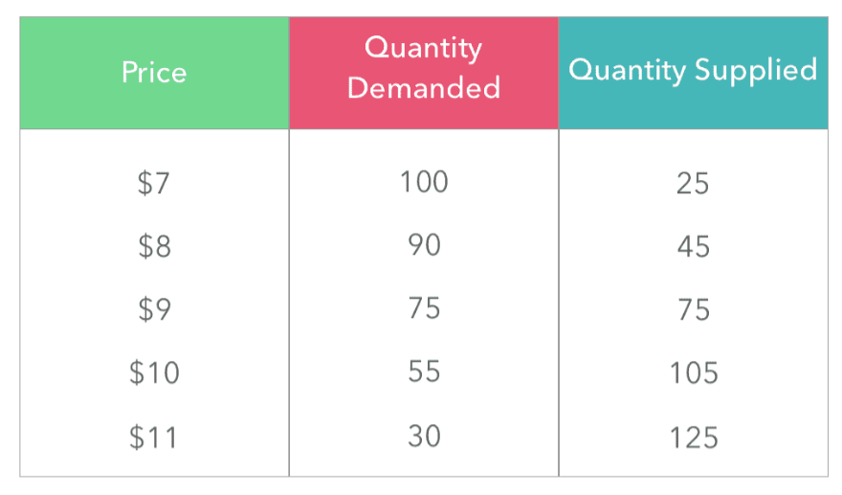

Answer:

(0.3333…)/(0.1053…) = 3.167

We get the price elasticity of supply when the price increases from $9 to $10 is 3.16. So for movie tickets,

The price is elastic and thus supply is very sensitive to price changes.

**\*\*Q5:**

1. *P = 500 - 3QD*; where P is price and QD is Quantity demanded of a normal good

i. If the income level increases from 10,000 BDT to 15,000BDT then what would happen to the overall demand?

Answer. (increases)

Ii. If the change in demand is a **parallel shift**, suppose a 10% change in demand, then what would be the new demand function?

Answer: new demand function=(P = 550 - 3QD)

iii. If the market price is 200 TK, what would be the income elasticity of demand?

Answer: (Find the old and new QD from respective functions and calculate YED with the given income and obtained QDs)

**Q6.** If the PES is 2.0 for pen drives: and the firm supplied 4,000 when the price was £40. If the price increased from £40 to £46, what would be the new Q?

Answer:

● Price increases by £6 (40-46), therefore as a % 6/40 = 15%

● PES = % change in QS/ % change in price

● 2.0 = % change in QS /15

● 30 = % change in QS

● Therefore new Q = 5200

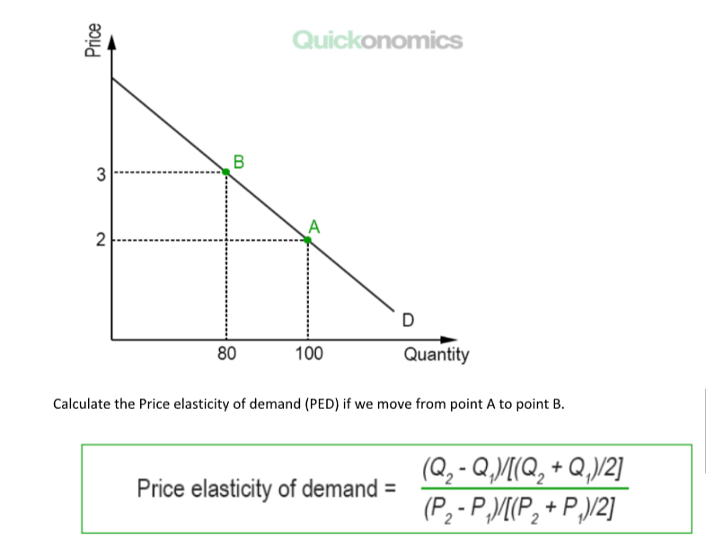

Solution: PED=0.55 (ANS)

Q. If price increases by 10% and consumers respond by decreasing purchases by 20% what will be the price elasticity of demand?

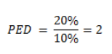

Question: Yesterday the price of envelopes was $3 a box, and Julie was willing to buy 10 boxes. Today, the price has gone up to $3.75 a box and Julie is now willing to buy 8 boxes. What kind of demand is Julie’s demand for an envelope? Explain.

Solution: PED=1 (unit elastic demand)

Quantity demand will respond proportionately to a change in price.

**Question:** If Neil’s elasticity of demand for hot dogs is constantly 0.9 and he buys 4 hot dogs when the price is $1.50 per hot dog. How many will he buy when the price is $1.00 per hot dog? (using the percentage change formula)

N=2.8

**Question:** Which of the following goods are likely to have elastic demand, and which are likely to have inelastic demand?

a) Home heating oil- (inelastic)

b) Pepsi- (elastic)

c) Chocolate-(elastic)

d) Water- (inelastic)

**Question:** Katherine advertises to sell cookies for $4 a dozen. She sells 50 dozen, and decides that she can charge more. She raises the price to $6 a dozen and sells 40 dozen. What is the elasticity of demand?

N=0.56

**MCQs**

1) If the elasticity of demand for college textbooks is -0.1, and the price of textbooks increases by 20%, how much will the quantity demanded change, and in what direction? *

a. The quantity demanded increases by 2%

b. The quantity demanded decreases by 20%

c. The quantity demanded decreases by 2%

d. The quantity demanded remains the same

2) If the elasticity of demand for spring break packages to Cancun is -5, and if you notice that this year in Cancun the quantity of packages demanded increased by 10%, then what happened to the price of Cancun vacation packages? *

a. The price fell by 10 percent

b. The price fell by 2 percent

c. The price increased by 2 percent

d. The price remained the same

3) In your college town, real estate developers are building thousands of new student friendly apartments close to campus. If you want to pay the lowest rent possible, should you hope that demand for apartments is elastic or inelastic? *

a. Elastic

b. Inelastic

4) In your college town, the local government decrees that thousands of apartments close to campus are uninhabitable and must be torn down next semester. If you want to pay the lowest rent possible, should you hope that demand for apartments is elastic or inelastic? *

a. Elastic

b. Inelastic

5) The long-run elasticity of oil demand has been estimated at -0.5. If the price of oil rises by 10%, how much will the quantity of oil demanded fall? *

a. 5%

b. 0.5%

c. 2%

d. 20%

6) The long-run elasticity of oil demand has been estimated at -0.5. Does a 10% rise in oil prices increase or decrease total revenues to the oil producers? *

a. Increase

b. Decrease

7) The elasticity of demand is 0.2. Is the demand curve relatively steep or flat? Will a fall in price raise total revenue or lower it? Note: we present the elasticity in terms of its absolute value. *

a. Relatively steep; raise total revenue

b. Relatively flat; raise total revenue

c. Relatively steep; lower total revenue

d. Relatively flat; lower total revenue

8) The elasticity of demand is 2.0. Is the demand curve relatively steep or flat? Will a fall in price raise total revenue or lower it? Note: we present the elasticity in terms of its absolute value. *

a. Relatively steep; raise total revenue

b. Relatively flat; raise total revenue

c. Relatively steep; lower total revenue

d. Relatively flat; lower total revenue

9) Henry Ford famously mass-produced cars at the beginning of the twentieth century, starting Ford Motor Company. He made millions because mass production made cars cheap to make, and he passed some of the savings to the consumer in the form of a low price. Cars became a common sight in the United States thereafter. Keeping total revenue and its relationship with price in mind, do you expect the demand for cars to be elastic or inelastic given the story of Henry Ford? *

a. Elastic

b. Inelastic

**MCQ solution**

1. c
2. b
3. b
4. a
5. a
6. a
7. c
8. b
9. a

because the percentage increase in quantity demanded is greater than the percentage decrease in price.

